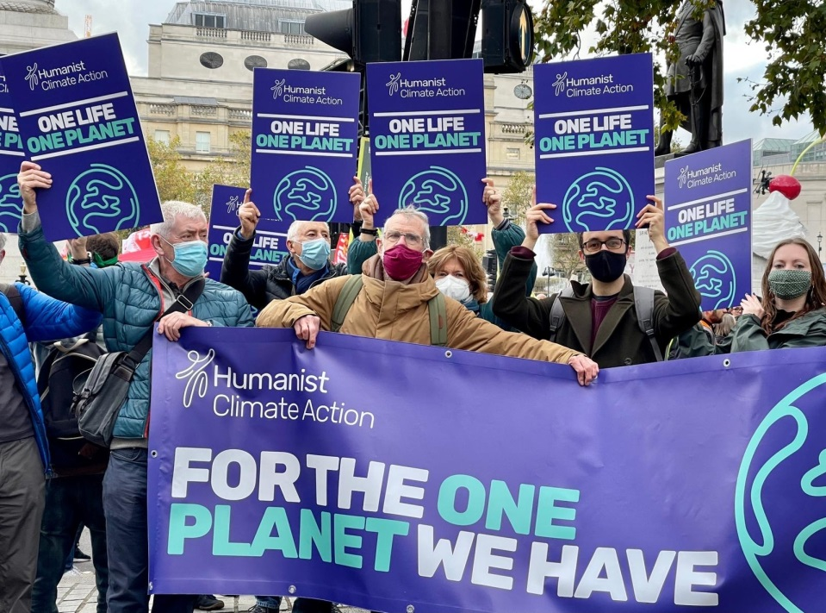

**Lori Marriott, Humanist – Humanist Climate Action Committee Coordinator**

**Why do you care for the earth?**

Humanists know that we cannot look to a higher power to solve our problems for us. We have to take responsibility for our own lives, for the lives of others. We believe that this life is the one life we have, and similarly, this is the one planet we have. We are therefore all the more keenly aware that our finite human lives are given meaning and purpose by our membership of an ongoing human community and the legacy we leave to future generations.

**How have your Humanist beliefs inspired your action on climate change and environmental issues?**

My humanist beliefs have really highlighted for me that humans are part of the wider natural world, not separate from it. We therefore have a moral and practical duty to treat it sustainably for the sake of current and future generations, and other species that we share the planet with. Unfortunately, we have not used the earth’s resources in a sustainable way, which is resulting in issues such as climate change and biodiversity loss. It therefore feels essential to readdress this and campaign to encourage individuals, governments and companies to prioritise sustainability.

**What do you do to put these beliefs into action?**

Humanist Climate Action is quite a new group – so far we have worked with several government and Select Committee consultations to encourage policy change. We have also joined with other faith and belief groups to campaign for climate justice, especially around COP26. We also try to encourage humanists to adopt greener lifestyles.

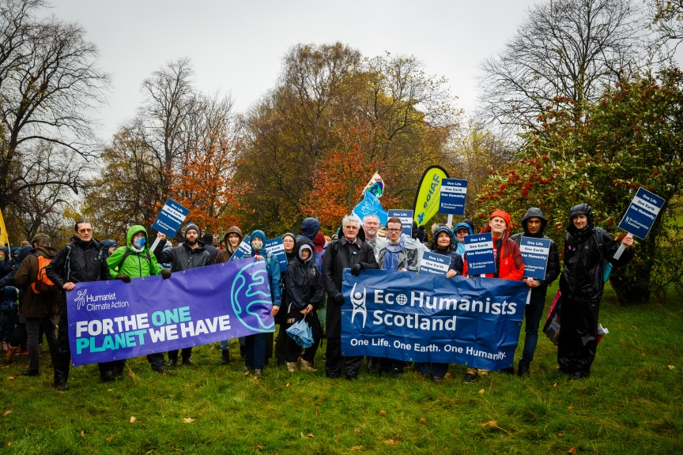[](https://humanists.uk/humanist-climate-action)

**Humanist Climate Action at a COP26 march**